Lab2 A Writeup

Source code for binary
#include <stdio.h>
#include <stdlib.h>
#include <string.h>

/*
* compiled with:
* gcc -O0 -fno-stack-protector lab2A.c -o lab2A
*/

void shell()
{
printf("You got it\n");
system("/bin/sh");
}

void concatenate_first_chars()
{
struct {
char word_buf[12];
int i;
char* cat_pointer;
char cat_buf[10];
} locals;
locals.cat_pointer = locals.cat_buf;

printf("Input 10 words:\n");
for(locals.i=0; locals.i!=10; locals.i++)
{
// Read from stdin
if(fgets(locals.word_buf, 0x10, stdin) == 0 || locals.word_buf[0] == '\n')
{
printf("Failed to read word\n");
return;
}
// Copy first char from word to next location in concatenated buffer
*locals.cat_pointer = *locals.word_buf;
locals.cat_pointer++;
}

// Even if something goes wrong, there's a null byte here
// preventing buffer overflows
locals.cat_buf[10] = '\0';
printf("Here are the first characters from the 10 words concatenated:\n\
%s\n", locals.cat_buf);
}

int main(int argc, char** argv)
{
if(argc != 1)
{
printf("usage:\n%s\n", argv[0]);
return EXIT_FAILURE;
}

concatenate_first_chars();

printf("Not authenticated\n");
return EXIT_SUCCESS;
}

- As we can see, the main function calls a function that creates a struct, then reads 10 words in, and prints out the first letter of each word.
- The first thing to note is that the index variable i is vulnerable to being overflowed, and because the loop merely checks i does not equal ten, we can overflow it, and then input as many words as we want, leading to further overflows.
This is the stack just after the call to concat_first_chars
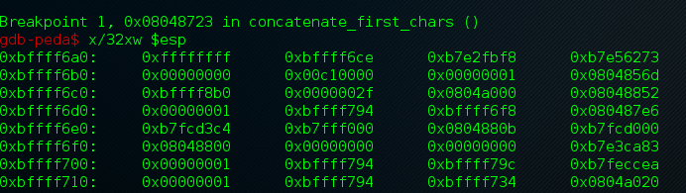

This is the state of the stack after one word has been entered.
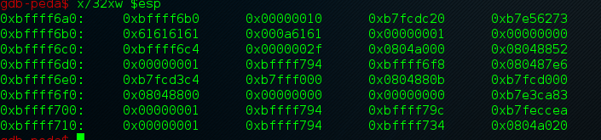

- So our first goal is to overwrite i, this is done by inputting 12 bytes, as the char word buffer only has space for ten bytes, these extra 2 bytes overflow into i.
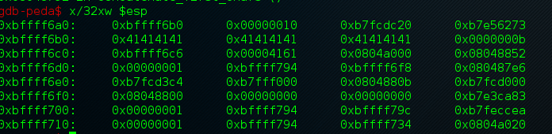

- Here, we have inputted 12 A's, the value at 0xbffff6bc is the value of '\n' after it has been incremented (i++). So our first payload is "A"*12 + "\n", where that 13th byte overwrites i.
- As we can see at 0xbffff6c4, we have the location of where each character is stored. Now we must overflow this and overwrite the return address of the function, this is located at 0xbffff6dc.
- Because we now have the ability to input as many words as we want, we simply need to find the offset of trash bytes, and then overwrite the ret address.
- After some experimentation, we find that we need 24 character pointers including the first overflow character.
- This is the state of the stack at the second overflow, we have halted just before overwriting EIP.
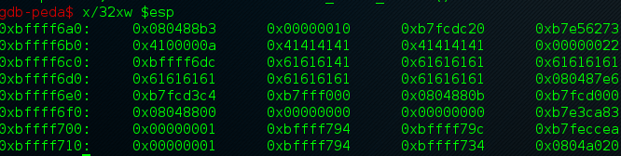

- Shell is at 0x080486fd, so we just need to input that. Our payload is hard to input to the program, so first we print it into a file, and then cat the contents of that into the program.
- The payload is:
- Now, if we try to cat this into ./lab2A, we get a segfault. This is because the program starts a shell process after we have closed stdin, so we need to keep stdin open. We do this using (cat payload; cat) | ./binary.
- The final exploit is as such
